A-level ICT
SENIOR Five term 3
TOPIC 1/2: Electronic Word Processing
Competency: The learner creates professional Word documents for effective communication.
Word processing software is a type of application program used to create, edit, format, and print text documents. It is one of the most widely used productivity tools in ICT.

Key Features of Word Processing Software
- Text creation & editing – allows typing, deleting, and modifying text.
- Formatting tools – change font style, size, color, and alignment.
- Spell check & grammar check – automatically detects errors.
- Insert objects – add tables, images, charts, and hyperlinks.
- Page layout options – adjust margins, spacing, and orientation.
- Templates – ready-made designs for letters, resumes, reports.
- Collaboration tools – multiple users can edit documents online.

Examples of Word Processing Software
Microsoft word, Google Docs, LibreOffice Writer, Apple Pages, WPS Office Writer

Uses of Word Processing Software
- Education – writing assignments, reports, and research papers.
- Business – preparing letters, proposals, and documentation.
- Personal use – resumes, invitations, journals.
- Publishing – creating newsletters, brochures, and books.

Tasks: Pleases perform the following numbers for practice
1 Type the text below using an appropriate word processing program
Nkondo primary school organized a sport day, all the pupils were divided into house and each house had a house leader elected by pupils of that house. The houses were Nile, Victoria, Kyoga and Albert. Victoria had its leader Catherine. All teachers liked Catherine because she was hardworking and well behaved.

Catherine was at first doing well, as she was practicing with her house members daily. Time came when she was doing the opposite. She became proud of herself in front of other pupils. Whenever she was given some items like glucose and sugarcane to be given out during practice, Catherine kept them to go and share with her friends in the dormitory. Her behavior did not please the members of the house. They decided to report the matter to the housemasters.

- Change the format of the first paragraph to italics (02 marks)
- Insert a name of your school as water mark (02marks)
- Change the font size of the whole document other than the heading to 13 (01mark)
- Add a suitable title to the text and format it with the Title style. (02marks)
- Justify the whole text. (02marks) (f) Insert boarders on the last paragraph.
- Add a footnote on the word assembled (which is underlined) with another word of similar meaning.
- Copy all the content of the document to a fresh page. (01mark)
- Insert any page number apart from the Arabic numerals (1, 2, 3 …..) on the top of the pages (02marks)
- Insert a footer of your name and personal number (01mark)
- Save document under your name and personal number and print your work. (01mark)
- (a) Type the text below using an appropriate word processing program (02 marks)
Waya primary school is a day school in the middle of Seseme village. In this school, lunch is given to those pupils whose parents have paid lunch.
One day, four boys and three girls studying in this school started their journey home, it was after the afternoon classes. None of their parents had paid the lunch money. These children were hungry and weak. On their way, they saw a mango tree with some ripe fruits on it.
“I am hungry; why don’t we visit that mango tree for fruits?” Bruno, one of the boys asked.
“Yaah”, his friend Robert shouted excitedly. The rest including the girls supported the idea.
All the seven of them approached the tree. They saw the ripe fruits. They started to throw some stones at them. One of the girls, Kawudha, said, “I see a bee-hive on that big branch” “we shall not climb but just throw stones. Makes sure you don’t disturb the bees,” Robert said.
  - Set the margins as Top 1”, Bottom 1”, Left 1” and Right 1” (02marks)
  - Format the text to font size 12 and apply double line spacing. (02 marks)
  - Apply a Drop Cap on the first paragraph. (02marks)
  - Highlight the second paragraph with yellow color. (01mark)
  - Split the third paragraph into two columns. (02marks)
  - Insert appropriate heading for the text. (02marks)
  - Draw a 4 ½ point colored line below the heading (02marks)
  - Insert a Watermark of your name (02marks)
  - Insert a picture of mango below behind the text of last paragraph (02marks) (k) Save and print your work (01mark)


- Type the text below using an appropriate word processing program. (02marks)
Last week, primary seven of Molo Boarding Primary School went for an educational tour. They visited Mrs. Byakiko’s farm at Kolonyi. This followed their lesson on domestic animals by Mr. Amu.
The pupils started preparing for the journey as soon as the lesson ended. Some children washed and ironed their uniforms; other wrote down question they would ask the farm manger.
The following Friday, they woke very early, to prepare. They bathed, dressed and had breakfast, immediately the school bus reached the packing yard, they just boarded. One their way, they saw many important place. Their social studies teacher showed them Mabira forest and Kakira factory. Other places were the Coca-cola industry and Kile Tea Estate. He told them how important these places were to the country.
At the farm, they were welcomed by Mrs. Byakika herself. They were all surprised to see the old woman managing the farm very well. She had only four workers. The farm was divided into two units. At each unit, she explained the activities that were taking place there. Some pupil asked question which she answered very well. She encouraged the pupils to start rearing cattle and birds in their homes. Many pupils left the farm promising to start their own farm when they grow up. Educational tours are inspiring.
- Type the passage and save it as your name and personal number. (02marks)
- Cut the last sentence of the text and paste is as a centered heading. (02marks)
- Double underline the heading. (01mark)
- Arrange your work in three columns except the heading. (03marks)
- Insert at the beginning of the first column the image school bus below and apply a tight text wrapping. (02 marks)
- Resize the picture to 1.12” height and 2.0” width. (02marks)
- Apply double line space and justify alignment to your work. (02mark)
- Insert a suitable work of your choice as a Watermark. (02marks)
- Apply a 6pt page border of any color around your work. (01marks)
- Insert your name, personal number and an automatic date as footer. (02marks) (k) Save and print your work. (01mark)


- (a) Using a suitable word processor, create the following table of information belonging to Madiba Enterprises Limited. Save it as your name and personal number.
Name | Age | Sex | Salary (Shs)
Munyagwa | 28 | M | 450,000
Bbaale | 30 | M | 550,000
Bena | 25 | F | 950,000
Namusisi | 26 | F | 380,000
Cosy | 27 | M | 400,000
Daniella | 32 | F | 600,000
Akella | 34 | F | 500,000
Faluk | 38 | M | 760,000
Kiwa | 37 | M | 850,000
Manafwa | 25 | F | 865,000
  - Make a copy of the table onto the next page. (01marks)
  - Sort the record in the table in descending order of Salary. (01mark)
  - Italicize the column heading and change them to font size 15. (02mark)
  - (i) add a row at the bottom of the table
    - Use in-built formulae to find the average age and total salary. (02marks)
  - (i) Insert a column to the right of the table and merge the cells
    - Type the text “salary is paid on 28th day of every month without fail” and align it vertically in the center. (03marks)
  - Insert a row at the top of the table and insert a suitable heading. (02marks)
  - Align your table in the centre of the table. (01 marks)
  - Insert a header containing your name and personal number in capital letters. (02marks) (j) Save and print your work. (01 mark)

- (a) You have been approached by a business man to help him typeset a credit note to be sent to various clients as indicated below.
    - Use any available word processing software and save your work as a credit note_001.
(06 marks)
P.O.BOX 01 HOIMA (U)

CREDIT NOTE

HOIMA
Credit Note No<<>> <<Date>>
<<Name of Business>>
<<Address 1>>

Dear Sir/Madam,
RE: CORRECTION OF INVOICE VALUES

Refer to invoice no.<<>>, due to changes in VAT rates and other discounts, the credit note values and adjusted totals amount to shs<<>> .
Please ensure you pay the adjusted invoice values in full by the invoice due date 10th August, 2015.
Yours faithfully
Kato Mark
Sales service
E & O E

    - The businessman has also provided you with the following details. Generate it in a different document and save as ‘credit_source’ Using mail merge facility, Merge the fields marked <<>> such that each member has a complete document for printing.
(06 marks)

Credit Note no. | Date | Name of  Business | Address 1 | Invoice No. | Amount
123 | 12/07/2015 | Jack suppliers  LTD | P.O. Box 01 Hoima | 0332510 | Shs.348,880
456 | 12/07/2015 | Mwebaza &  distillers  LTD | P.O. Box 02 Hoima | 045210 | Shs.452,000
878 | 12/07/2015 | BB & CC  LTD | P.O. Box 03 Hoima | 055210 | Shs.84,000

    - Add footer your name and header your personal number. (01mark) iv. Add page number in the format of page 1 of 3. It should be automatic. (02 marks)
v. Insert today’s date and allow a provision for automatic updating. (01 marks) vi. Insert an embedded object below yours faithfully to work as your signature mark (03 marks) vii. Complete merge and print out the three letters of your document. (01 mark)

TOPIC 2/2: Electronic Spreadsheet
Competency: The learner organises, manipulates, and visualises data to draw insights for data driven decision-making.
Electronic Spreadsheet software
Electronic spreadsheet software is an application program used to organize, analyze, and store data in tabular form. It allows users to perform calculations, create charts, and manage large sets of information efficiently.
Key Features of Spreadsheet Software
- Rows and columns – data is arranged in cells for easy organization.
- Formulas and functions – perform calculations automatically (e.g., SUM, AVERAGE, IF).
- Data analysis tools – sorting, filtering, pivot tables, and conditional formatting.
- Charts and graphs – visualize data trends (bar, line, pie charts).
- What-if analysis – test scenarios using tools like Goal Seek.
- Collaboration – multiple users can edit spreadsheets online. • Automation – macros and scripts for repetitive tasks.
Examples of Spreadsheet Software
Microsoft Excel, Google Sheets, LibreOffice Calc, Apple Numbers and Zoho Sheet
Uses of Spreadsheet Software
- Education – managing student grades, timetables, and research data.
- Business – budgeting, financial analysis, inventory management.
- Personal use – expense tracking, household planning.
- Data science – organizing datasets before deeper analysis.
In short: electronic spreadsheet software is a powerful tool for organizing, calculating, analyzing, and visualizing data across education, business, and personal use. Task: perform the following numbers for your practice

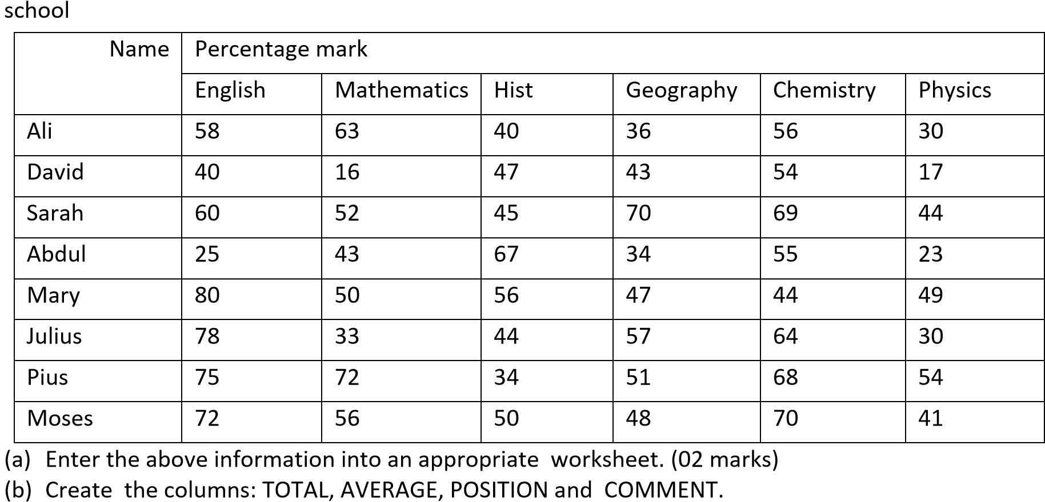
- Thefollowing is a end of term marksheet in % for S4 students of of term 1 of Balumya secondary
  - Use appropriate formulas to detrmine for each student the:
    - TOTAL mark (02marks)
    - AVERAGE mark (02marks)
    - POSITION (03 marks)
    - COMMENT promoted fot position 5 or below and Repeat otherwise.
  - Insert a column chart showing students total mark. Include chart and axes titles (04marks)
  - Insert a header of your name and personal number (01 mark)
  - Save and print your work

- The following students sat for their term two examinations in Mathematics (mat) Cmputer studies (comp) and Commerce (com) and obtained the folowing marks.
John scored 40 in mat, 20 in comp and 50 in com. Mary scored 90 in mat, 60 in comp and 30 in com. Tania scored 70 in mat, 65 in comp and 90 in com. Samuel scored 55 in mat, 40 in comp and 80 in com. Paul scored 50 in mat, 20 in comp and 35 in com. Albert scored 50 in mat, 60 in comp and 50 in com. Cissy scored 60 in mat, 70 in comp and 50 in com. Mersey scored 20 in mat, 90 in comp and 77 in com. Muzamil scored 80 in mat, 69 in comp and 50 in com. While Timothy scored 30 in mat, 60 in comp and 57 in com.
  - Enter the given data in a spreadsheet using appropriate column headings and table title. Save your work as your name and personal number. (06marks)
  - Use a formula in column E to compute the average score for each student and name it AVERAGE MARK. (02 marks)
  - Sort the data in desending order based on column E (01mark)

- Incline the column headings to anangle 45⁰ (02marks)
- (i) Create a column graph for students’ marks in the three subjects. Label your graph appropriately.
(ii) Move the graph to a new sheet and rename it as students’ Marks (04marks
- Use an appropriate formula in column F to grade the students with the criteia below
EXCELENT for all students with an average mark of 70 and above
PASS for those with an average mark of 50 and above, but less than 70 and FAIL for all students with an average mark below 50. (03marks)
- Apply all border on the data. (01marks)
- Save and print all your work. (01mark)

3. The statistics below shows the rainfal in millimeters (mm) received in Kisoro district in 2012:
January 63 Febuary 81 March 117 Aptil 186 May156 June15
July 12 August 36 September 147 October 144 November 153 December 60
- Use any spreadsheet application to eneter the data above Save it as your name and personal number (06 marks)
- Insert a suitable heading for the data. (02 marks)
- Use appropriate formulae to compute the rainfall received every month in:
  - 2013, if there was an increase of 5% from the previous year 2012. (02marks)
  - 2014, if there was a decrease of 10% from that of 2013. (02marks)
- (i) Create a 3-D coumn chart showing month and actual rainfall received in the 3 years. (03marks)
(ii) Insert a suitable title for the graph and label the axes. (02marks)
- Insert your name as header and personal number as the footer. (02marks) (f) Save and print. (01mark)

